**IFT 266 Introduction to Network Information Communication Technology**

**Lab 11**

**Configuring Network Time Protocol (NTP) on multiple devices**  
Co-Authored by Rashaun Khoo  
  
**After you complete each step, put a ‘√’ or ‘x’ in the completed box**

**Objective**

Whatever you do on a network there will always be a time when an event occurs. However, the time shown on multiple devices may not be the same as their clocks are not synchronized. This is where the use of NTP comes in, it allows a device to change their clock to be the same as the other device.

The goal of this lab is to set up an NTP server and synchronize the clocks of two routers to that server. This ensures that both routers would be using the same clock whenever an event occurs so that the user can relate the events with similar time.

1. 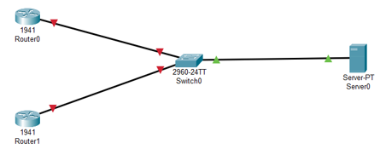Setup the following topology in packet tracer.



1. Configure the IP addresses for the two routers. Enter the following commands into Router 0.

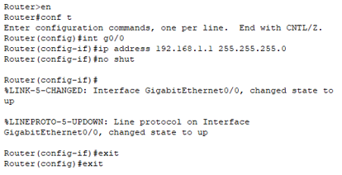



1. Repeat a similar configuration for Router 1 with the IP address of 192.168.1.2 and the same subnet mask as Router 0.



1. Going back to the topology make sure that the link between the routers and the switch are now green.

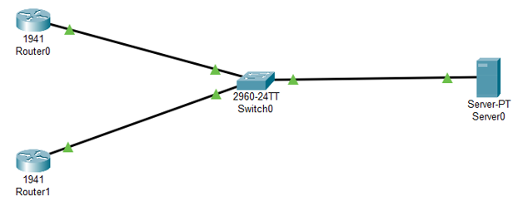



1. You now need the server to be able to communicate with the routers. Configure the server with the following IP address and subnet mask.



1. Now verify that the server can speak to both routers by pinging their IP address. You should get the following results.



1. Before we set up the NTP server, lets check the clock of both devices to see what it looks like before any changes are made.



Using the “show clock detail” command on Router 0, we can see that the device is using the hardware calendar to tell time. The same should apply to Router 1.



Using the “show ntp status” command for both devices we can see that the NTP is not enabled since we haven’t configured them yet.

1. Back at the server, go to the services tab and click the NTP option. The service should be on by default, if it is not then turn it on. The date and time should display the real-life date and time.



1. After ensuring that the NTP service is turned on, we can configure the NTP on the routers. In Router 0, enter the following commands.

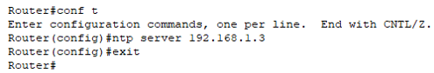

The “ntp server” command followed by the IP address of the server tells the router to change it’s time and date to match the server’s time and date.



1. To verify that this worked, enter the “show clock detail” command again. This time it should be using the NTP server as source and display the correct time and date.  
     
    (Note that it might take a few minutes before the change takes effect)



1. Using the “show ntp status” command should display that the clocks are now synchronized and which IP address the NTP server is referencing.

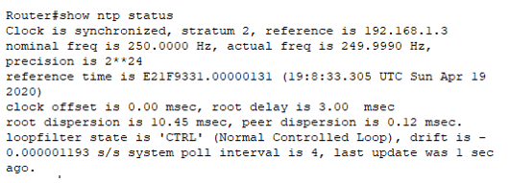

1. Using the same process, configure the NTP for Router 1 and verify it. They should display the same time and date as Router 0.